**December 18, 2019**

**Dear Jane**,

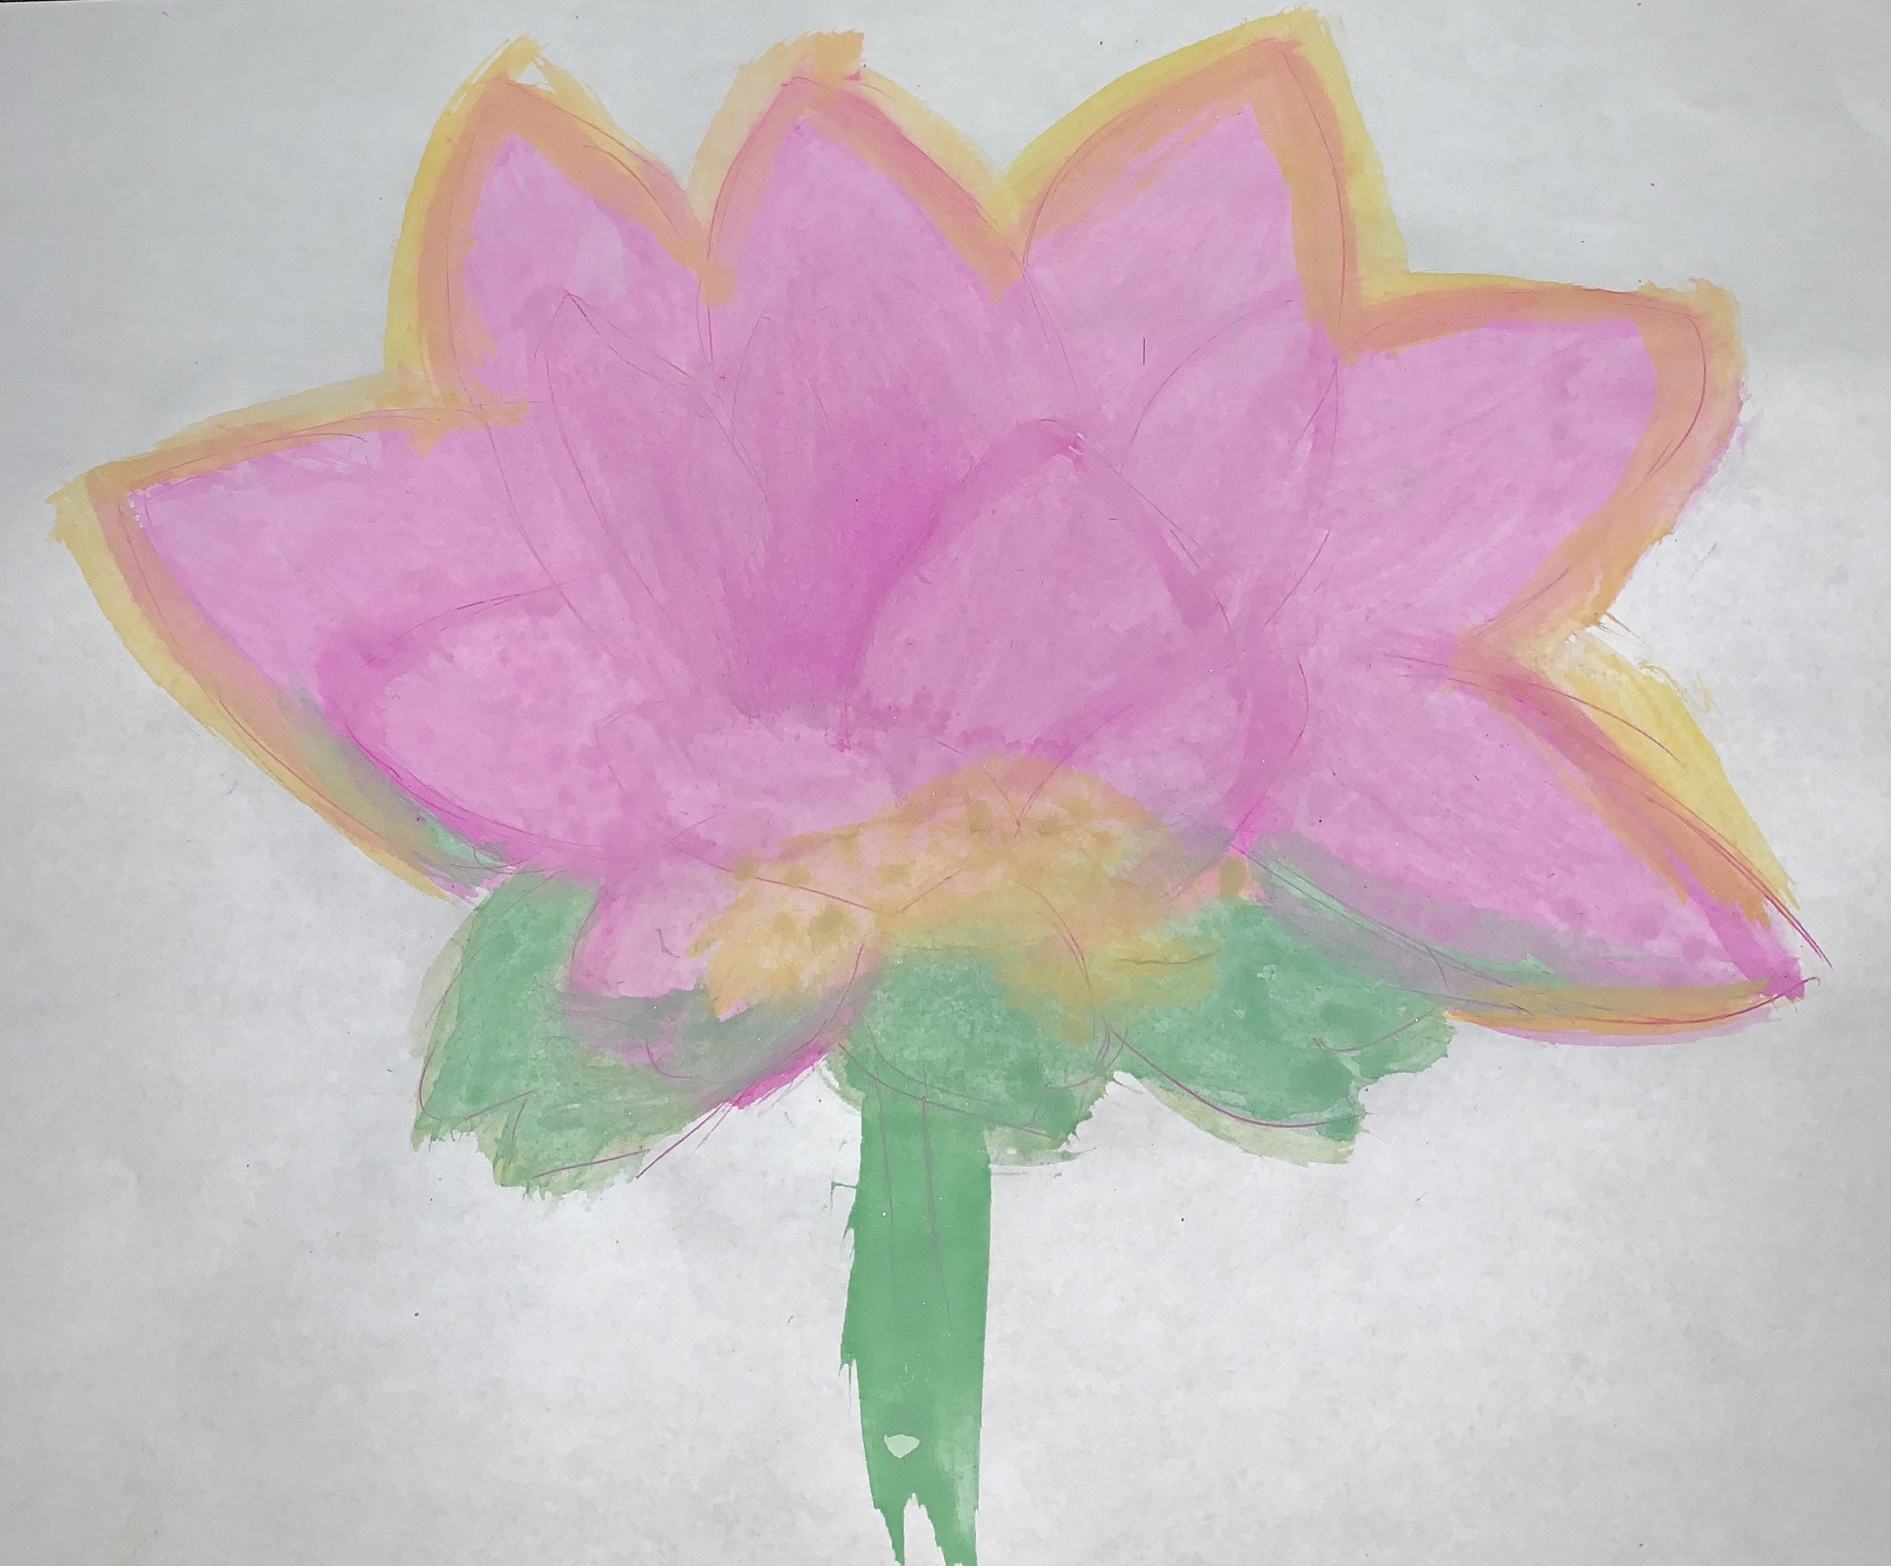 This class was very entertaining and fun. Every paper I wrote improved my writing and how I evaluated research papers and information found online. From the very first paper which was “Field Study,” I collaborated with my **classmates** on writing projects: **research papers**, in-class presentations and **peer reviews**, used **CCNY’s library** resources and online databases/the Internet to locate sources appropriate to my writing projects, practiced and strengthened summarizing, paraphrasing, quoting, analyzing, synthesizing, and **citing sources** by completing assignments, determined my own **writing goals**, developed and strengthened an appreciation for different **audiences**, **identified the audiences** who will read my writing -- and worked to understand them, acknowledged my **classmates** as we worked together to correct each other’s papers, and finally I created this digital portfolio. The photo above is what I drew for my Field Study Paper. This paper introduced me to the APA format and creating my own **audience**.

Every assignment tested me as a writer by having me do research and focus on a specific **audience**. It tested how well I can find information and cite them correctly. Reading someone else’s paper gave me ideas about what more I can write on my paper and offered me confidence as at this time I knew my first draft on going in the right direction. This also relates to the New York Times articles I completed. Reading and summarizing the New York Times articles helped me keep up with what was going on in the science world as it kept me up to date with current events which helped me pick my topic for my controversy paper. I read and wrote about smoking ban policies on two of my papers. My scientific controversy paper was about if smoking should be banned in public places? and my scientific rhetorical analysis was about smoking ban policies and their influence on smoking behaviors among current California smokers.

My habits as a writer were that I would set up my space on my desk. I would clean my desk as removed all unnecessary paper which is not part of what I am writing about. Then I would grab two bottles of water and close the door. After this I would begin to start writing. I always began to write my paper at night because I find everything more relaxed. Depending on how I feel I would either listen to music or not. When I started the semester, I would not check back on my work as I would just submit it, but now I always double-check my work to see small errors I might have made. One skilled I improved is citing evidence and paraphrasing it. Jane’s comments on my papers helped me understand how checking back on your work will always improve your writing. One thing I will always remember to do is cite the photographs and authors I include in my paper.

In the end, my journey in this class was exhilarating. Creating the digital portfolio will be the final step in this journey as I move on to my next challenge in City College of New York. You were an excellent professor who helped me improve my writing and reading skills. One assignment I enjoyed doing the most was the collaborative project. Everyone in the class was involved and I enjoyed writing about my experience in the class and what’s really beyond the syllabus. I can’t wait to see how this collaborative project comes out.

Sincerely,

**Mohammed Nahiudzzaman (Mo)**